**Digital Design (CSCE 2114) – Lab 4**

Objectives:

* Learn how to use the Mega Function Wizard to design a complex circuit. In this lab you will create an adder/sub.
* Learn how to simulate your design before implementing it on the FPGA to verify that it works.

Note: → means “Next” button

# A. Using the Mega Function Wizard for building an add/sub

1. In Quartus, create a new project (license: 1800@csce-licsrv.ddns.uark.edu).
2. Add a new *Block Diagram/Schematic File* to your project and save it with its default name.
3. Double click in the schematic window and click the MegaWizard Plug-In Manager button. →
4. Click on + next to Arithmetic and choose LPM_ADD_SUB, then specify a name for the output file (such as *Mega*). →
5. Select the *Create an ‘add_sub’ input port* option. Click Finish.
6. If a dialog box pops up, click *Yes*. Then click *OK* in the Symbol window and add the adder/sub to your schematic.
7. Connect appropriate input/output pins as pictured below. Notice that buses are named as an array, like X[7..0]. Also make sure that the pins are connected. Save the file.

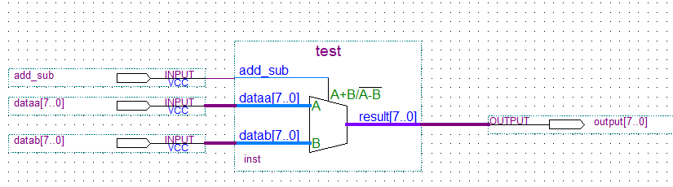

1. Click *Start Compilation* ( C:\Users\blittman\Desktop\Untitled.jpg ). You can ignore any compilation warnings, but not errors.

# B. Adding a test bench for input signals

1. Create a new *Vector Waveform File.*
2. Right click on the left panel and choose *Insert* > *Insert Node or Bus...*
3. Click *Node Finder…* and in the new window select *Pins: all* from *Filter.* Click the *List* button. Select *add_sub, dataa, datab, etc.* (hold Ctrl to multi-select). Click the > button. *OK, OK.*
4. While holding Ctrl, scroll the mouse wheel to zoom out. Now, you are able to see the whole time frame starting from 0ns to 1000ns.
5. You can choose which format you prefer to see the bus values. While holding Ctrl, select *dataa, datab, and output*, then right-click and select *Properties*. Change the Radix to Unsigned Decimal.
6. Click the Waveform Editing Tool (  ). Assign a new arbitrary waveform to *add_sub* by clicking and dragging the cursor tool across the desired time zone of the pin:



1. By clicking + next to *dataa*, you will see its bits (7 down to 0). Change four of its bits using  as seen below, then collapse *dataa* (- button). You need to do this for at least 5 different test cases.

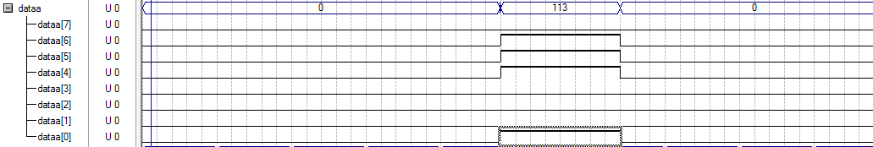

1. Right click on *datab* > *Value* > *Count Value...* In the Counting tab, change the Increment value to 2. Now select the Timing tab and change the values to:

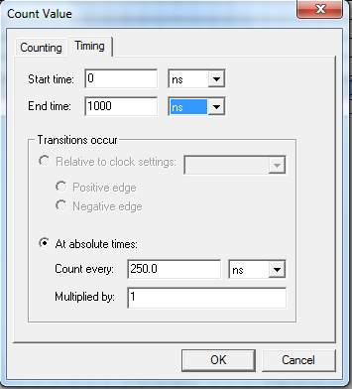

# C. Simulation results

Now it is time to simulate your design. Do NOT click the  symbol, it will crash Quartus.

1. Save the waveform file.
2. Open the simulator window by clicking “Processing” > “Simulator Tool”
3. Make sure the name of your waveform file is in the Simulation input dialog box.
4. Check the Generate VCD file box and change the path of the file to your desktop. Name the file Lab4Sim.vcd
5. Click Start
6. We will use Modelsim to view our simulation results due to compatibility issues with the Quartus simulation window in Windows 10.
7. Open Modelsim-Altera 10.4d
8. Close any dialog boxes that pop up.
9. Create a new project by going to File > New > Project…
10. Name the project Lab4_username and click Ok.
11. Close the Add items to Project box.
12. In the Transcript window at the bottom of the screen, type the command:

vcd2wlf <path_to_your_vcd_file> <path_to_new_wlf_file>

Ex. vcd2wlf C:/Users/aaa000/Desktop/Lab4Sim.vcd C:/Users/aaa000/Desktop/Lab4Sim.wlf

1. To open the simulation results, click File > Open… Change the Files of Type drop down to “Log Files (.wlf)” Then navigate to your newly created Lab4Sim.wlf.
2. In the Objects Pane, select all of the pins, right click them, and “add wave”
3. If you expand the waveform window and press “F” on your keyboard it will fit the contents to the screen and you will be able to view your simulation results.
4. You can select the multi-bit outputs and right click them to change the radix to “unsigned.” This will show the results as decimal numbers instead of binary.

Check out the waveform for the *output* pin in the Simulation Report. You can experiment by changing the waveform for any of the input pins and running the simulation again to see how it affects the output.

